**Project Final Report**

**Course Information**

**Course:**  CSE 480 Web Database Programming (Sections 1)

**Instructor:**  Abdus Satter, Adjunct Faculty, CSE Dept.

**Project Name**

|  |  |
| --- | --- |
| **Title of Project** | Online News Portal |
| **Student**  **(ID & Name)** | Moni Kishore Dhar (2016-2-60-099) |

**Project Purpose**

The purpose of the online news portal is to give the public the opportunity to read and search up-to-date news, as well as to give authenticated users the opportunity to comment on specific news.

**Project Goals and Objectives**

The goals and objectives of the Online News Portal are as follows:

1. To provide immediate storage and retrieval of data and information to get all kinds of instant and important news for all viewers.
2. To provide a free text search function facility for all news seeker.
3. To provide a secure account management function for admin and viewers.
4. To allow authenticated viewers to comment on specific news.
5. To provide an efficient news management functions to the admin panel to publish news as well as delete and update news.

**Project Description**

The system that is going to be developed is Online News Portal System. This is a database application system that is to be used by the public to read and search news in anytime and anywhere. The system keeps the record of all the admin, authenticated viewer. This system also has the ability to keep track of the news as well as comment record. This project intends to computerize online news portal system in order to provide the instant and important news and also to provide searching facility due to the grown size of records of news. As well as this project have the intention to publish all kinds of important and breaking news in order to expose the truth to everyone due to the grown size of fake and biased newspaper.

**Scope**

As a whole the system is focused to work with online news portal system and on additional modification it can be also used as publication systems of similar organizations.

**System Users**

* **Administrator:** Has full privilege on the system's functions including admin panel maintenance.
* **Admin Panel:** Has full privilege on the news and comments functions.
* **Authenticated Viewers:** Has privilege in own comments function.

**Database**

A complete ER Diagram for the system:

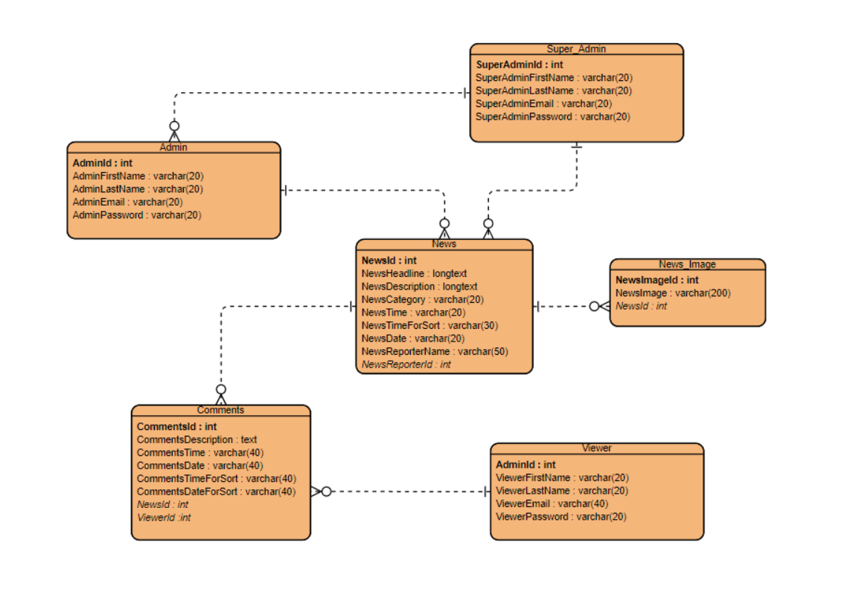

**Processes**

* **Login:** The system provides security features through username-password matching where only authorized user can access the system with different authorization level. This system has three authorization level. Administrator, Admin Panel and Viewer.

Log In page of Administrator: Log In page of Admin Panel:

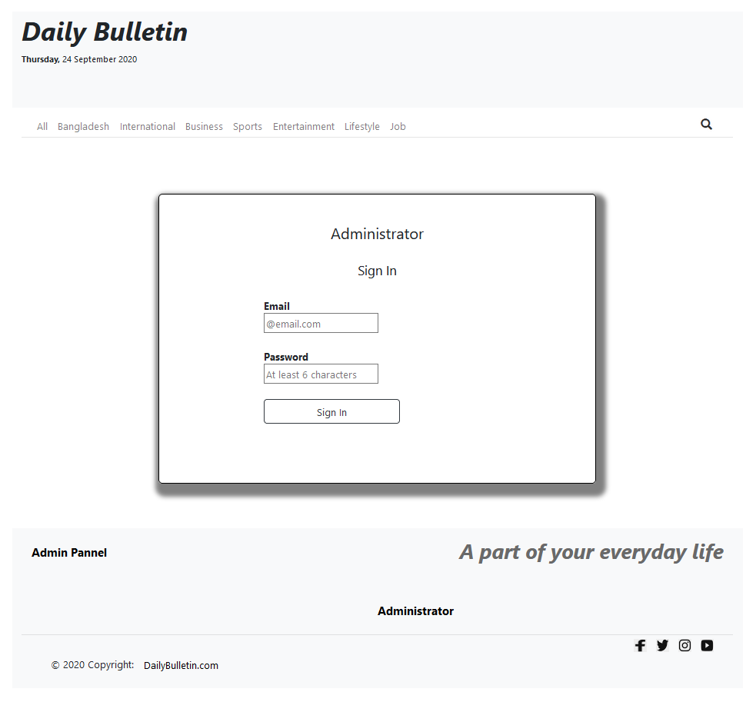 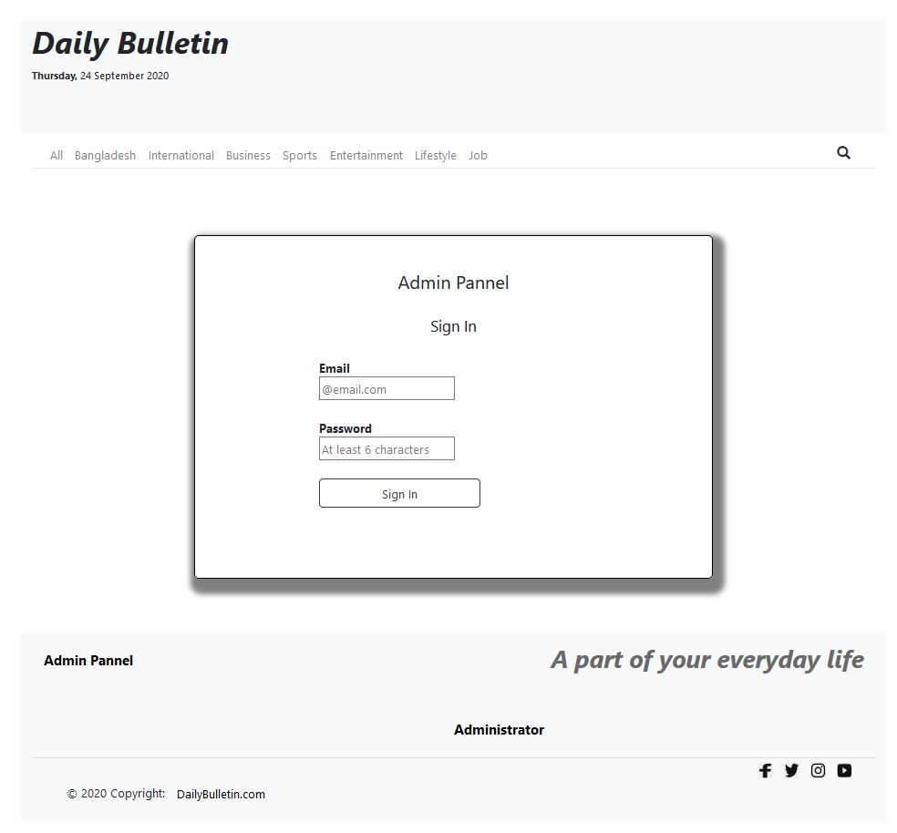

Log In page of Viewers:

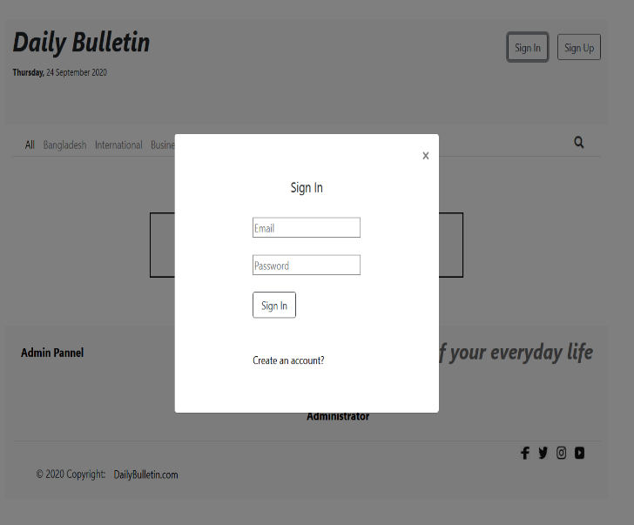

* **Viewer Profile Registration:** This system allows to register as viewer to read as well as comment on news.

Viewer Registration Page: Viewer Comment Box:

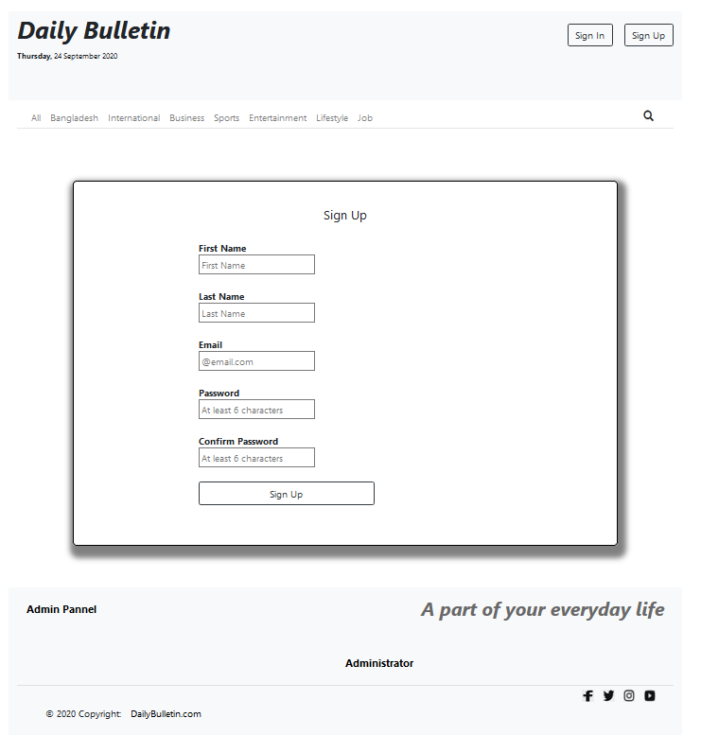 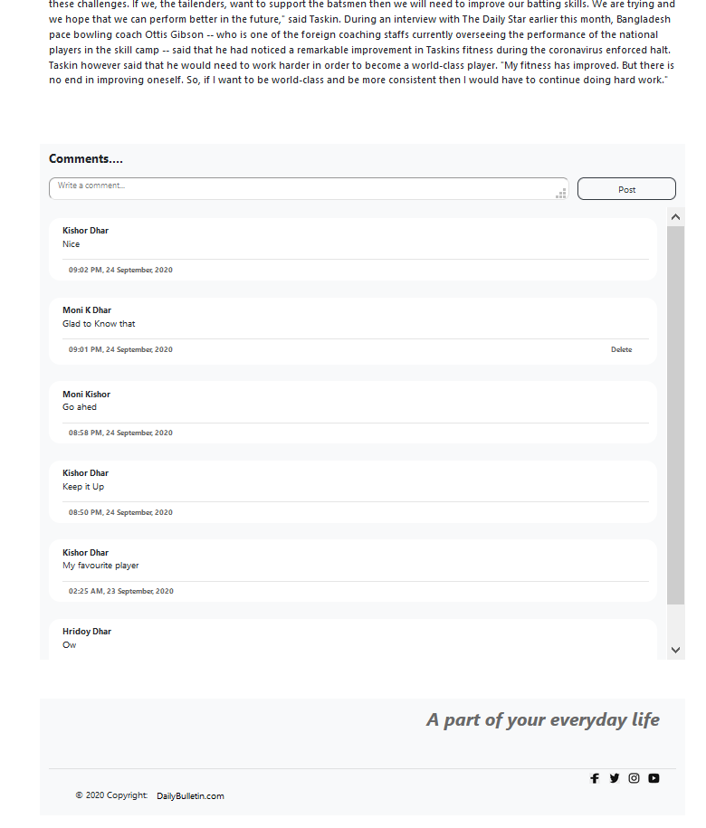

* **News Management:** The admin panel can manage the news to add, update, delete news through this system. Each process or work-flow can be traced from the database. The admin panel can also control the comments on news through this system.

News management Functions: Admin Comment Box:

 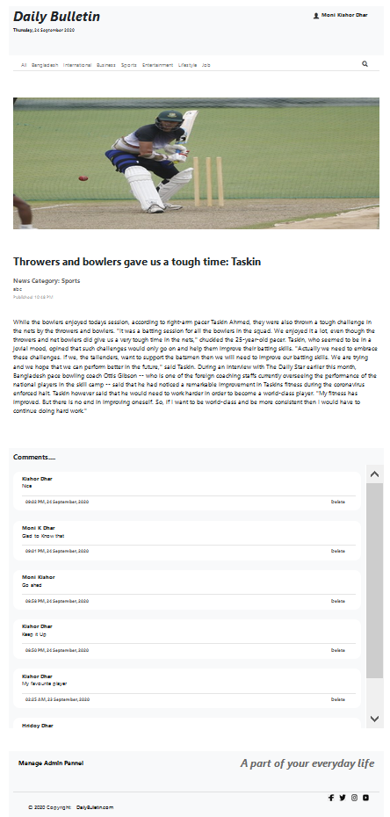

* **Admin Panel Management:** The records of all admin panel and viewers are kept in one centralized database. The record of admin panel is maintained by the administrator through this system.

Admin Panel Management Box:

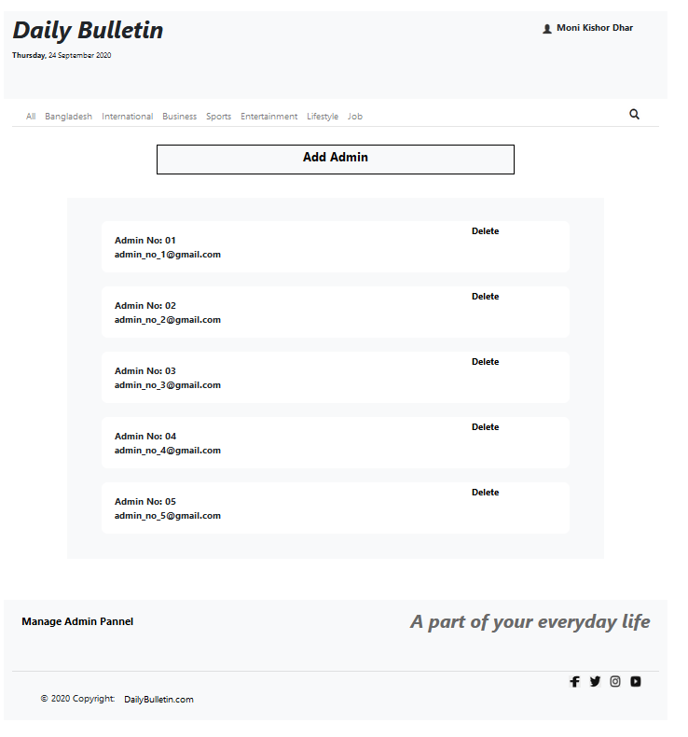

* **Search:** All users can search with any key value for the news through this system. Also users can search with news category, reporter name, date, time etc.

Search Result Box:

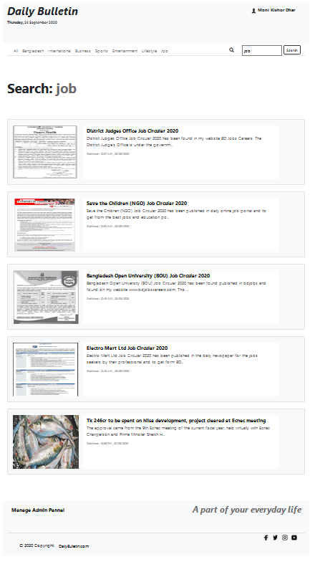

* **Single Page News View Module:** Users can view a specific news in a single page through this system.

Single page news view module:

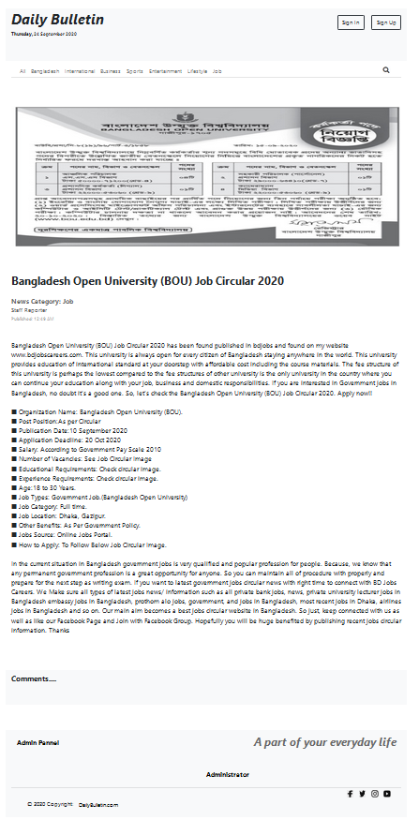

**Technology**

**Frontend Language: PHP**

**Backend Language: MySql Database**